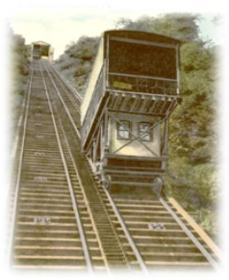

JOHNSTOWN BRANCH September/October 2024
ORGANIZATIONAL CHANGE
by Georgia Yeager
gayeager@gmail.com

Our AAUW Johnstown Branch continues into the 2024-25 membership year despite the lack of an elected President. Fortunately, the Executive Committee, a division of the Board of Directors, has agreed to act as Branch Leadership for a year. While the Board of Directors is made up of elected officers and committee chairs, the Executive Committee is made up of only the elected officers of the Branch.
Thus, the following comprise the Executive Committee:
President (open position)
VP of Programming - Dr. Valerie Grash
VP of Membership - Dr. Debe Mack
Treasurer - Claire Montoya
Secretary - Diana Price
At the Board’s transitional meeting in June, it was determined that Dr. Debe Mack, assisted by Claire Montoya, will lead the Branch from July 1, 2024 to December 31, 2024.
Then Dr. Valerie Grash, assisted by Diana Price, will lead the Branch from January 1, 2025 to June 30, 2025.
Hopefully a member or members will step forward to assume the office of President or Co-presidents before the May 2025 annual meeting when election of officers will occur. Thanks to these individuals for their willingness to go above and beyond!

UPCOMING EVENTS

Monday, September 16
2:00 pm at Cambria County Library
Book Discussion of “The Dressmakers of Auschwitz” by Lucy Adlington and led by Maria Cuccaro.

Wednesday, September 18
6:00 pm at Cambria County Library Community Room
Membership Business Meeting:” Current Initiatives for Johnstown” program

Thursday, September 26
6:00 pm at Highland Library, Richland
Book Discussion of “Rena’s Promise” by Rena Kornreich Gelissen and led by Ashlee Kiel

Wednesday, October 2
7:00-8:30 pm at UPJ Murtha Center
Public Policy Program “The Impact of the PA School Budget on Local School Districts”

Tuesday, October 15
2:00 pm at Young Heart’s Bookstore, Westmont
Book Discussion of “Born Survivors” by Wendy Holden and led by Andrea Santoro

Thursday, October 17
5:30 pm at Classic Elements
Book Discussion of “Irena’s Children” by Tilar Mazzeo and led by Georgia Yeager

Johnstown Branch AAUW Website
http://www.aauwjohnstown.org

 Fa

 IN MEMORIAM
by Kathy Howanek
khowanek@hotmail.com

We celebrate the life and legacy of Sara Suppes Ashman, who was the branch’s oldest living member until her passing on June 7th of this year. Joining in 1950, Sara had been a member for 74 years following in the footsteps of her mother, Marion Dibert Suppes, a founding member of the Johnstown Branch. Thanks to the efforts of Georgia Yeager, the branch renewed contact with Sara who was living with her daughter Sara Ashman Cifrese, M.D. in Idaho. Not only did this enable us to remember Sara on her birthdays, but Dr. Cifrese was exceptionally helpful in gathering information and photos to be used in our 50 -year plus video. The following are some excerpts from Dr. Cifrese’s letter to the branch celebrating our 100th anniversary:
“My grandmother Marion Dibert Suppes was surely one of your earliest members. Her father in the late 1800’s allowed each of his three daughters two years of education after high school. …She and her 1903 Harvard graduate husband found education even for women paramount……My mother, Sara Suppes Ashman, is a 1934 cum laude graduate of Bryn Mawr college. Because of the depression her father would not allow her to study math as that might deprive some man of a job…...I was told by my mother to do and become whatever I wanted…...my hope for organizations like AAUW is to advocate for women as my mother counseled me, to do and be whatever they want. It has taken three generations, privilege and over 100 years for my family. Let’s break down the barriers and see the timeline shortened for our sisters everywhere.”
We are fortunate to have a record of the continued passion for women’s equality in this family of women.
This link will take you to the 50-year video. Sara’s story begins at 40 minutes.
https://www.youtube.com/watch?v=MFQlfJrg_Ro&ab_channel=CambriaMemory

NEWSLETTER CHANGE
by Pat Grzybicki
dsap@atlanticbb.net

In an effort to streamline our newsletter and not be redundant, please be advised that we will no longer publish regular Social Group activity details.
You should be receiving email information from the leader if you are already participating in these activities. If you wish to join any of the groups listed to the left, you may contact the listed individuals by email. If you do not use email, please consult your Membership Yearbook for contact phone numbers. Thank-you.
NOTE: Dates and times will appear on the calendar page when available.

AAUW IN ACTION
SOCIAL GROUP CONTACTS
TUESDAY BOOK CLUB
2ND Tuesday afternoon of each month
Ann Furlong: akfurlong@verizon.net
BOOKS @ BOULEVARD
2ND Thursday of each month at 6:00 pm
Pat Grzybicki: dsap@atlanticbb.net
Shellby Custer: shellbyc@aol.com
DINING CLUB
3RD Wednesday of each month; 5:45 pm
Ann Furlong: akfurlong@verizon.net
THIRSTY THURSDAY
as scheduled by Kenna Raymond:
kennaraymond@gmail.com

EDUCATION/SCHOLARSHIP COMMITTEE REPORT
by Madeline Gyure
madelinefgyure@gmail.com

We again were successful in awarding Leora G. Rager scholarships of $2000 each to three very deserving local young ladies and a minority scholarship in cooperation with the Greater Johnstown Minority Scholars Club (GJMSC). Thank you to Education Committee members Claire Montoya, Eloise Romano and Andrea Santoro, who, along with myself, presented these at the high school awards ceremonies this past spring. We also, for the first time, partnered with member Laura Huchel, who is a Princeton graduate, to award the Princeton Book Award to a junior at Greater Johnstown. The Leora G. Rager awardees have all sent lovely thank you notes which will be available for review at the September membership meeting.

The online voting to either keep or eliminate the annual rotation of the high schools that receive the Leora G. Rager scholarships was completed on July 1st. Those without email were each contacted by phone by two individuals to verify their votes. A total of 56 members voted with a majority of 38 members voting to keep the current system of rotation. For the 2025 giving year, the scholarships will be awarded to young women from Bishop McCort, Ferndale, and Westmont High Schools. We are hopeful that we can maintain the amount of the scholarships at the $2000 level. As always, this is dependent on the success of the AAUW book sale and other fund raisers.

The Education Committee will meet in the early fall. They will continue to review our selection and awarding process and will consider whether or not they want to recommend any other changes to the Board, and subsequently to the general membership. Any member who has thoughts or suggestions on this topic may contact me or one of the Education Committee members. We also will decide whether to make the Princeton Book Award a permanent part of our annual awards process.

Under the auspices of the Education Committee a small ad hoc Holocaust Committee was formed to direct the AAUW participation in the “Hope Springs Eternal; the Holocaust Project”. In cooperation with two libraries and three local, independent book stores in Johnstown, we have organized four book discussions for the fall on books dealing specifically with the roles of women during the Holocaust. We are proud to be participants in this community-wide project as a way to participate that fits within our organizational mission of promoting literacy and educating people about the importance of the roles of woman in history. Members are encouraged to visit the Hope Springs Eternal web site and view the events, and specifically to look at the AAUW book discussions and register for one or more of them. Additional discussions will be scheduled in March and April, along with a demonstration of Jewish cooking in March.

A poster page is included at the end of this newsletter for you to copy and post as you wish.

https://hopespringseternalproject.com/aauw/

2024 AWARDEES
by Georgia Yeager
gayeager@gmail.com

BOOK SALE 2024 UPDATE
by Ann Furlong
akfurlong@verizzon.net

Thanks to the hard work of all of us (including friends and family) we had a most successful book sale. The cooperation of all was amazing, especially for tear down on the last day. We definitely earned the celebration dinner at Anthony's afterward!
A big thank-you goes out to everyone who helped in any way. That includes the sorters, packers, collectors, and schedulers. Their work began long before Sale Week. Then there are the many hours that were given the week of the sale for set-up, selling, replenishing and tearing down. What an achievement!
Give yourselves a big pat on the back. And know that we start all over again on October 4!!! Yes, that is a fact. The fall collection will begin on October 4 and run until the 26th. So be prepared to say "yes" when you are asked to collect and/or sort. This is how we fund our scholarships and also how we make lasting friendships within our AAUW Johnstown Branch. So, enjoy September and be ready for October.

Book Sorting and packing will be on Mondays and Thursdays from 1:00-3:00 as in the past on these dates: Oct.7, 10, 14, 17, 21, 24, 28, 31, (Nov. 4, 7 as needed).

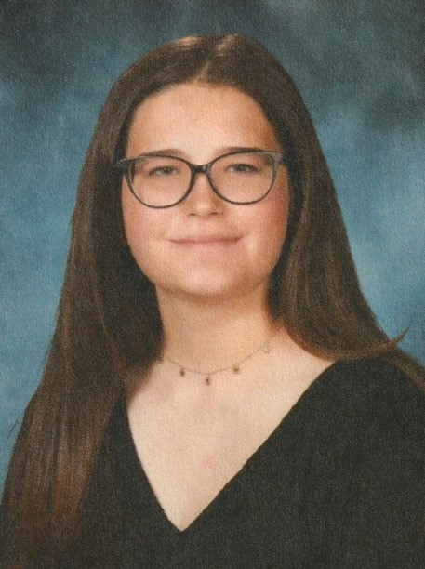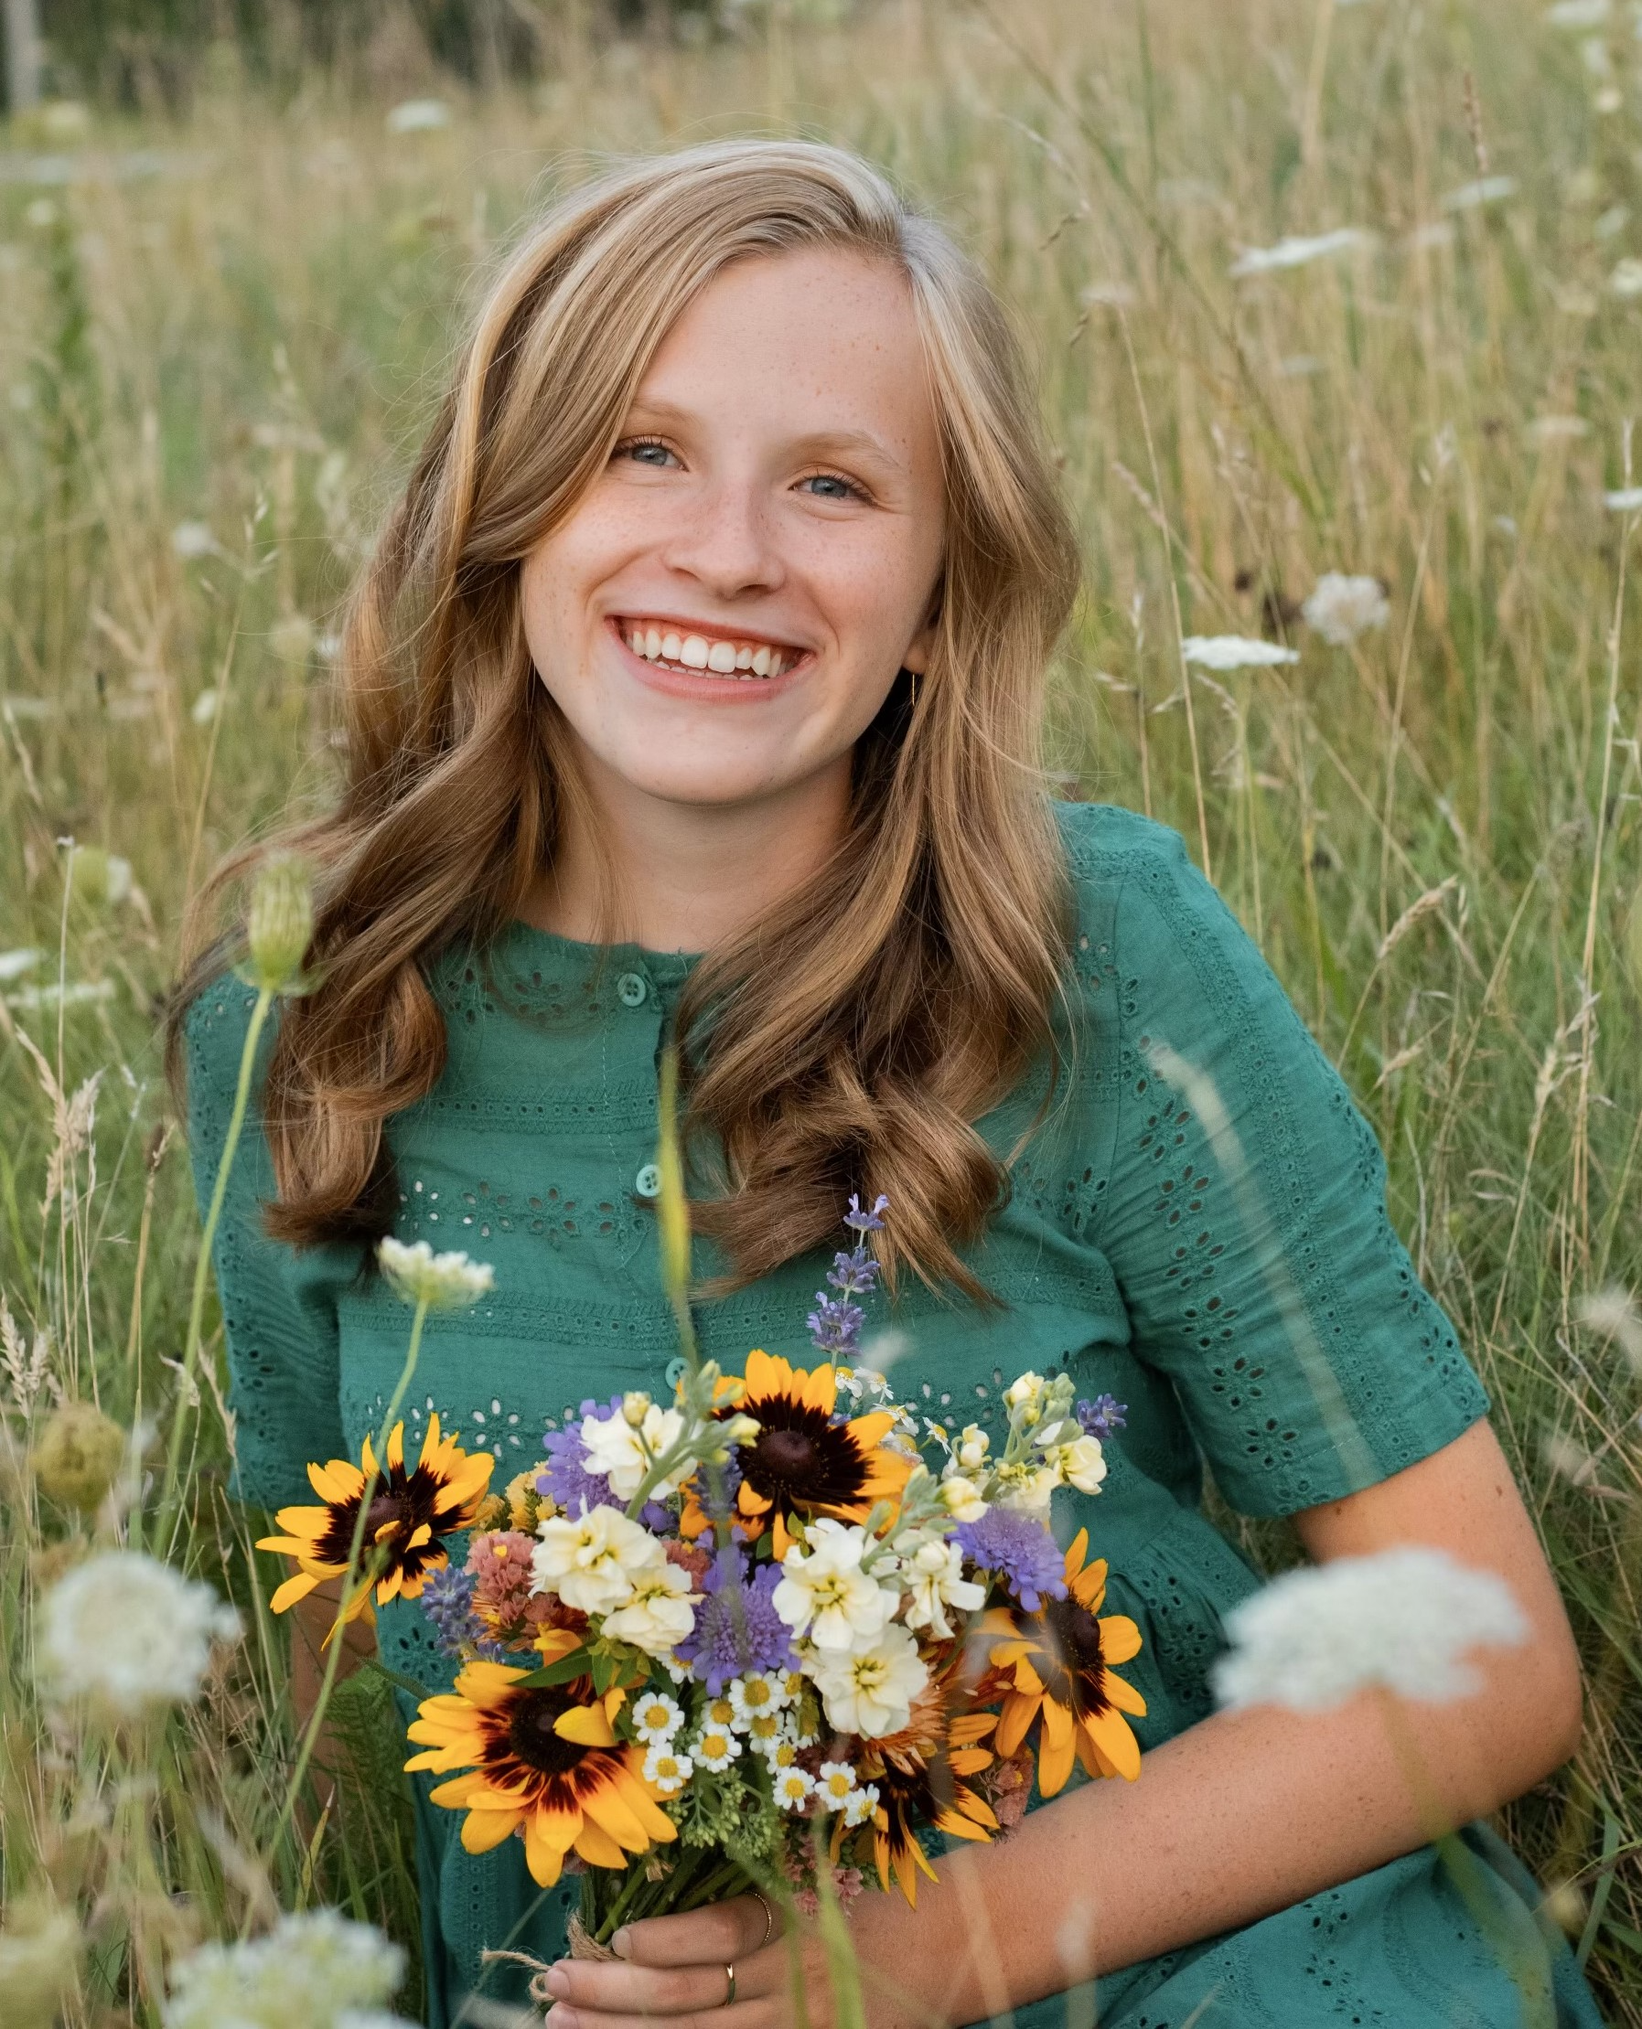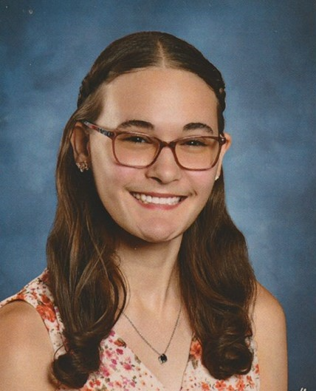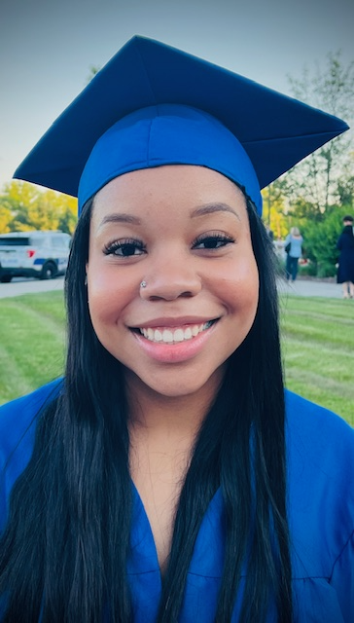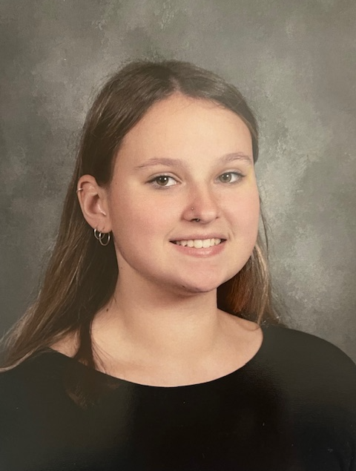

Young women from Cambria County schools have received AAUW Johnstown Branch awards as follows (pictured left to right):
The Leora G. Rager Scholarships were given to Rylee Cameron (Windber SD), Katelyn Turley (Conemaugh Township SD), and Meghan Kennedy (Greater Johnstown SD).
Kennedy Brassell (Richland SD) is the recipient of a scholarship given by both AAUW Johnstown Branch and the Johnstown Minority Scholars Club.
Madelyn Wilfong (Greater Johnstown SD) is the Princeton Award winner selected by AAUW and the Princeton Club and is the recipient of a special book by a Princeton author.

La Crosse WI 54601

BRANCH FINANCES IN ORDER
by Georgia Yeager
gayeager@gmail.com

The Finance Committee met via Zoom on July 22, 2024, to review the finances of the fiscal year and to receive the report of the Branch Financial Reviewers. The financial review of the records of Claire Montoya, Financial Officer, was conducted by Sara Barron and Dr. Nina Girard. As in previous years, all of the records were found to be in good order, and the reviewers praised the record keeping of the Financial Officer.

On June 30, 2024, at the close of the fiscal year, there was $10,049.39 in checking and $16,276.39 in savings for a balance on deposit of $26,325.78. There is a total of
$43,121.25 in the Community Foundation for the Alleghenies (CFA). Approximately half of that amount at CFA is in an endowed scholarship fund (for a future AAUW scholarship) and the other half, while invested with CFA, is still available for the Branch’s mission-related activities should the Branch need the money.

This Photo by Unknown Author is licensed under CC BY-SA
COMMUNITY OUTREACH OPPORTUNITIES
by Kathy Howanek
khowanek@hotmail.com

In response to the enthusiasm and involvement of the membership for last year’s community outreach projects, four such opportunities have been scheduled for the branch in our coming business year. The projects that were chosen have some connection with the branch or some of our members.
- In celebration of our C/U Affiliate, we will begin the year with a collection of food and personal care products to benefit the UPJ Student Food Pantry. Members can bring items for donation to the September Branch Meeting. Member Joyce Radovanic will arrange delivery. Suggestions for needed products along with an alternate form of donating will be sent in a separate email.
- The collection at December’s Holiday celebration will once again benefit the Cambria County Literacy Council. Member Heidi Staib, a Literacy Council volunteer, will accept the donation on the Council’s behalf.
- Our February meeting will benefit the West End Food Pantry where member Eileen Tweed volunteers and will schedule our delivery.
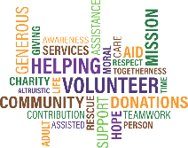
- And because we had such a great turnout last year, Kenna Raymond has arranged for our members to “stuff the backpacks” for the Cambria County Backpack Project on Monday April 14 from 4-5:30 p.m. Kenna will be
- recruiting 15 volunteers closer to the date.
It is hoped that you will participate as you are able!
PUBLIC POLICY UPDATE
by Deanna Haddle

jdhadd1@gmail.com
On October 2, 2024, the Johnstown Branch AAUW, in cooperation with the Education Division of UPJ, will be holding a public forum on “The Impact of the PA Education Budget on our Local School Districts.” The program will be held at the Heritage Hall in the Living and Learning Center on the UPJ campus from 6:30 PM–8:30 PM. This event is free and open to the public.
The speakers are:
Dr. Charline Rowland, UPJ Division Chair of Education
Dr. Amy Arcurio, Superintendent, Greater Johnstown School District
Nicole Dull, Superintendent, Conemaugh Township School District
Deanna Haddle, Johnstown Branch AAUW
Thomas Mitchell, Superintendent, Westmont Hilltop School District
Susan Spicka, Executive Director, Education Voters for PA
The AAUW Public Policy Committee is asking all AAUW members to be present, if possible. Our AAUW-UPJ affiliate members will be helping at the event and we want them to see the viability of our membership. We are hoping to have parents from local school districts and taxpayers who will be directly affected by this information in attendance.

CAMPUS/UNIVERSITY AFFILIATE
by Dr. Nina Girard
nina@pitt.edu

With the start of a new semester and school year, the University of Pittsburgh at Johnstown AAUW Affiliate is eager to get started! Joyce Radovanic and myself, University Liaisons, staffed the AAUW-UPJ booth at the Student Involvement Fair on-campus. This recruitment event provided exposure to the student body about AAUW as an organization, and information was provided on membership and preliminary plans for affiliate activities on-campus. A total of sixteen students signed up as being interested in the affiliate, and an organizational meeting will be held soon.
University affiliate members will be asked to assist at the branch’s Public Policy Panel Event on school funding and budgets, to be held at the UPJ Murtha Center on October 2nd.

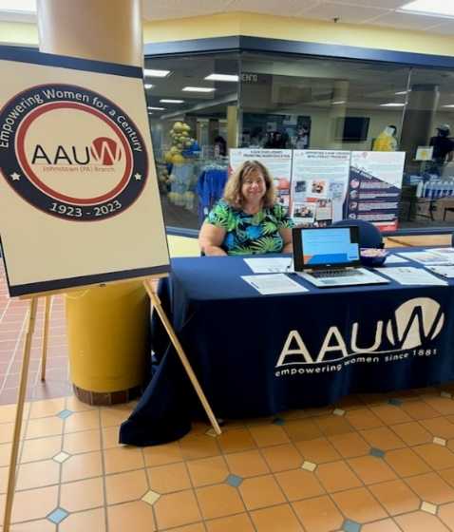
Dr. Nina Girard, University Affiliate Liaison
at the AAUW-UPJ booth at the on-campus Student Involvement Fair


SEPTEMBER 2024

SUN | MON | TUES | WED | THURS | FRI | SAT
1 | 2 | 3 | 4 | 5 Thirsty Thurs 6pm  Craft | 6 | 7
8 | 9 | 10 2nd Tue Bk 1pm HRSL | 11 | 12 B@B  6pm | 13 | 14
15 | 16 Bk Dsc  CCL 2pm | 17 | 18 Mem Mtg CCL 6pm | 19 Dining Club 5:45 Wine Loft | 20 | 21
22 | 23 | 24 | 25 | 26 Bk Dsc  Highland Lib 6pm | 27 | 28
29 | 30

OCTOBER 2024

SUN | MON | TUES | WED | THURS | FRI | SAT
 |  | 1 | 2 Pub Pol Program UPJ 7pm | 3 Thirsty Thurs 6pm  The Fifth | 4 | 5
6 | 7 Bk St | 8 2nd Tue Bk 1pm  DL Home | 9 | 10 B@B  Bk St | 11 | 12
13 | 14 Bk St | 15 Bk Dis  YHB 2pm | 16 Dining Club 5:45 | 17 Bk Dis  CE 5:30pm  Bk St | 18 | 19
20 | 21 Bk St | 22 | 23 | 24 Bk St | 25 | 26
27 | 28 Bk St | 29 | 30 | 31 Bk St

