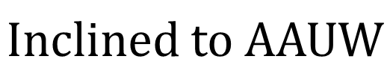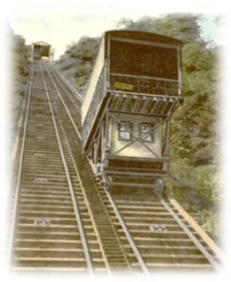

JOHNSTOWN BRANCH May/June 2026
ELECTION 2026
by Shellby Custer
shelllbyc@aol.com

At our annual End-of-Year Membership Meeting on May 18 we will elect officers for the upcoming year. This year we vote on President, Vice President of Program, and Secretary. Per our bylaws, the slate of officers is to be presented to the membership at least 30 days prior to the election. It is listed below.
(Please note that you may still self-nominate or offer nominations up to the election.)

The 2026 Nomination Slate is:
President: Madeline Gyure
VP Program: Co- chairs: Georgia Yeager and Shellby Custer
Secretary: Co- officers - Kristie Murray (Board meetings); Nina Girard (Membership meetings); Robbin Hofman (Correspondence).
Thank you to those who are stepping up to lead us into the future. It is an important role that you take to honor the mission, vision and values of our organization. Your Nominating Committee (Andrea Santoro, Nina Girard, & Shellby Custer)
Mission Statement: To advance gender equity for women and girls through research, education, and advocacy.
Vision Statement: Equity for all.
Values: Non-partisan. Fact-based. Principled. Inclusive and Intersectional.

Thank you-

Your Nomination Committee (Andrea Santoro, Nina Girard, & Shellby Custer)


UPCOMING EVENTS
Wednesday, May 6, 2026
Public Program: Jane Addams
7-8:30 pm at BMHS Toyota Media Center

Wednesday, May 13, 2026
Girls Just Want to have Fun trip to
Westmoreland County Museum of American Art 2:00 pm

Monday, May 18, 2026
Business Meeting /Covered Dish
4-7 pm at Highland Regional Park, Pav 1

AAUW IN ACTION
SOCIAL GROUP CONTACTS

TUESDAY BOOK CLUB
2ND Tuesday afternoon of each month
Ann Furlong: akfurlong@verizon.net
BOOKS on THURSDAY
2ND Thursday of each month at 6:00 pm
Pat Grzybicki: patgrzybicki@gmail.com
Shellby Custer: shellbyc@aol.com
DINING CLUB
3RD Wednesday of each month at 5:45 pm
Mary Kay Milavec: mkmilavec@verizon.net
Kenna Raymond: kennaraymond@gmail.com

THIRSTY THURSDAY
as scheduled by Kenna Raymond:
kennaraymond@gmail.com

I

Johnstown Branch AAUW Website
http://www.aauwjohnstown.org

 Fa

This Photo by Unknown Author is licensed under CC BY-NC


PRESIDENT’S MESSAGE
by Madeline Gyure
madelinefgyure@gmail.com

It has been a busy Spring! Our March 21st meeting was held in the community conference room in the Conemaugh East Hills Building, which was an excellent location. Thank you to Carol Keppel for suggesting it! We are welcome to utilize it again. While the library renovations continue, we may be in need of alternative meeting locations.

At this membership meeting, Dr. Lori Woods, President of the Indiana Branch and State Programming Chair, gave an inspiring talk to about 27 of our Branch members. Lori introduced us to a number of the speakers who will be at the September Atlantic Regional Conference, an impressive lineup of State and National leaders. Some of the topics include voting rights, sexual harassment, reproductive rights, threats against journalists, constitutional rights, and immigration. The theme for the Regional Conference, which is being hosted by Pennsylvania this year, is “The Unfinished Revolution.” Dr. Woods also talked about leadership and the personal rewards one can gain from getting more involved in AAUW at a local or State level. Finally, she spoke to the importance of engaging local students and mentoring future leaders through the Affiliate Programs.
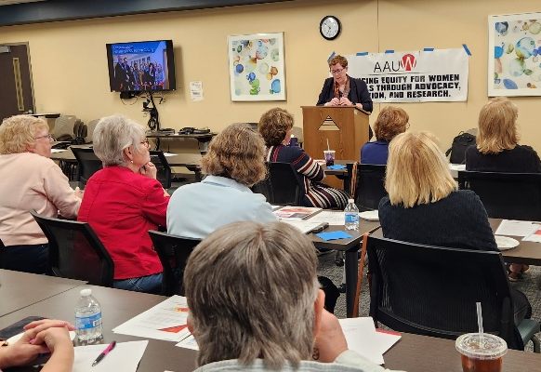
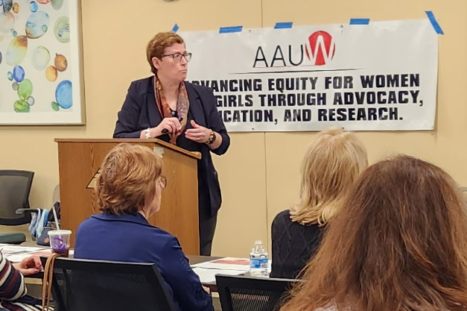

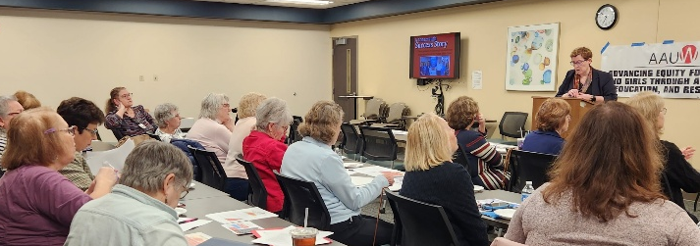

On March 6th. I presented our annual Gateway to Equity Award to Andi Palmar for the work that her organization, Operation BeYoutiful, does for local women and girls dealing with medically-related hair loss.
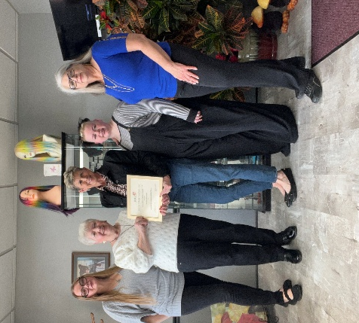
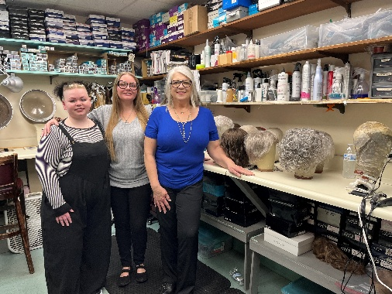
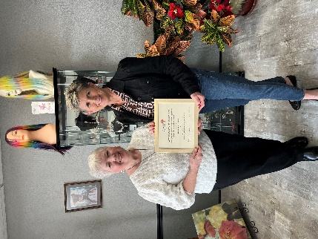
In Keeping with Woman’s History Month and the Semiquincentennial year, Dr. Paul Newman spoke to a group of close to 100 Branch members and members of the community on March 18th. His topic, “Women in the Revolution,” was fascinating and very informative. His presentation was videoed, and once I finish editing and inserting his PowerPoint slides, we hope to have it on our website for the remainder of the 250th Anniversary year. So, those of you who missed it will have the opportunity to see it.
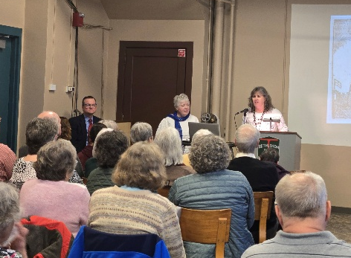
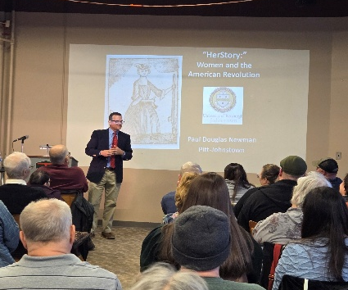

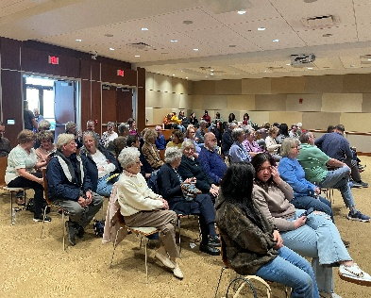
On April 8th, Dr. Mark DiMauro presented a program on AI to a group of about 80 at the John P Murtha Center on the UPJ campus. The program was interactive and the response, both that evening and since, has been very enthusiastic. We have much to learn, and Dr. DiMauro has agreed to consider doing a sequel next year.
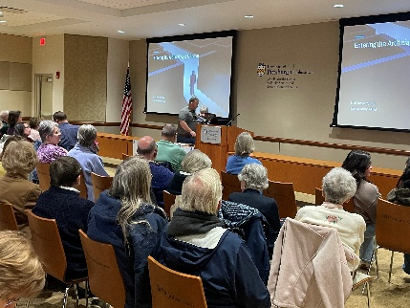
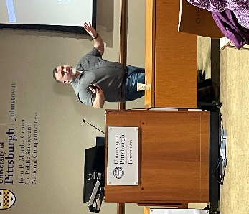
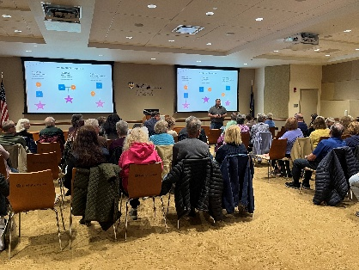
Thank you to our prior Program Committee Chair, Dr. Valerie Grash, for planning these three interesting events, and to the Programming Committee members who helped make the programs happen, especially Andrea Santoro.

The final public educational program has been organized by the Education Committee and will be held on Wednesday evening, May 6th at Bishop McCort. Dr. Dan Santoro will speak on Jane Addams who is considered “The Mother of Social Work.”

Finally, our annual end of year membership meeting/picnic is scheduled for Monday, May 18th at the Highland Park pavilion. We will present our three annual awards at this time. This is a covered dish event. The details as outlined by Program Committee member Heather Brice are as follows:

MEMBERSHIP MEETING AND COVERED DISH

WHEN: Monday May 18, 4- 7 pm
WHERE: Highland Regional Park, Pavillion 1, (flat/easy access)
Playground Drive Johnstown, PA 15904 highlandregionalpark.org
WHAT: 1. Covered Dish – Chicken Tenders, Water and Iced Tea provided.
Please bring a covered dish according to the first letter of your last name:
A – G: Appetizer H – S: Salad or Side Dish T – Z: Dessert.
2. Membership Meeting and election of officers



COMMUNITY OUTREACH
by Kathy Howanek
khowanek@hotmail.com

Thanks to all who donated at the March meeting, we collected $225.00 to support the
United Way Diaper Bank!

Our final outreach project is participation in Penn Highlands One Book Project for
middle schoolers. The call for volunteers came from project director and friend of the
branch, Barb Zaborowski:
“It’s that time of year when we are preparing for this year’s One Book, One Community Middle School Reading Program and we need volunteers. This year’s event is May 18, 19, and 20 from 10:00 a.m.-1:30 p.m. Volunteers need to be at the college by 9:00 a.m. each day. Lunch will be provided for all volunteers.
We need people to serve as group leaders and to assist in the hands-on stations. This year’s stations include: telegraph office, medical tent, air dry take away, and water pressure.”
To volunteer, complete this survey https://www.surveymonkey.com/r/OBOC2026volunteers
Several members have volunteered for Tuesday, May 19 but if you can’t make it on
Tuesday, please consider one of the other days! It’s a fun and educational event. The
book that will be featured is “Flooded: Requiem for Johnstown” by Ann E. Berg.

The Community Outreach committee will meet over the summer to review and schedule
next year’s events. If you have any suggestions, contact Kenna Raymond or
Kathy Howanek. If you volunteered to serve on the committee, you will be contacted for the summer meeting.


BOOK SALE 2026 UPDATE
by Ann Furlong
akfurlong@verizon.net

As this newsletter is being distributed, the spring book collection is coming to an end. Book sorting hopefully will finish in the following week to ten days. As usual the community has been most responsive to our appeal for their used books and we have received many wonderful volumes. And again, you all have been so faithful in following the collection and sorting/packing schedules. It has been said before, but bears repeating: this sale cannot take place without the help of all who are able to assist. And you have met the challenge. This will be another successful sale.
So, pat yourselves on the back, take a well-deserved time out and then be ready to sign up for work times at the sale itself. Book sale set up will happen on August 3 and 4. Sale dates are August 5, 6, 7 and 8. Worker’s sign-up will begin at the May 18th membership meeting.

See you at the sale!


MEMBERSHIP COMMITTEE UPDATE
by Dr. Debe Mack
debemack@gmail.com

Our AAUW Johnstown membership is holding strong at 73 members. That kind of consistency comes from members who stay engaged and continue to support our work.

As we move into renewal season, please take a few minutes to check your membership status through the AAUW website. You will also receive a reminder email from the branch, prior to your renewal dare, to make it easy to stay current.

Looking to get a little more involved this year? We have committee opportunities available across membership, events, communications, and outreach. Whether you have an hour a month or want to take on a larger role, there is a place for you.

Have a friend who has been thinking about joining? This is a great time to invite them in. Through the Shape the Future program, new members can join at a reduced rate. They simply need to complete the new member form and submit it with payment to Debe for processing, or send in their information for outreach.

Lastly, if you have photos from events or programs, keep them coming. Those snapshots tell the story of who we are better than anything else!


PUBLIC POLICY REPORT
by Deanna Haddle
jdhadd1@gmail.com

IMPORTANT DEADLINES for the 2026 PA PRIMARY ELECTION
May 4, 2026 –
Last day to register to vote
May 12, 2026 –
Deadline to request a mail–in ballot
May 19. 2026 –
Deadline to return your mail ballot. It must be received at your county election office by 8:00 PM
May 19, 2026 –
Election Day

Cambria County Election Office Location:
200 South Center Street
Ebensburg, PA 15931
Phone: (814) 472-1460
PRIMARY ELECTIONS ARE IMPORTANT!

Local and State officers control elections, schools, taxes, etc. Plus, you pick national candidates for your political party. Please Vote!

The Branch Public Policy Committee held two GOTV (Get Out the Vote) postcard writing events in April. Thank you to all who attended. Your support is appreciated. The committee members will be meeting at the end of April to start working on our Public Policy October program. If any other members would like to suggest a topic for this program, please contact Deanna Haddle: 814-659-1682.
This Photo by Unknown Author is licensed under CC BY-NC-ND


EDUCATION COMMITTEE REPORT
by Heidi Staib
staibfam@aol.com

The Johnstown Branch of AAUW 2026 Scholarship recipients have been chosen and will be recognized at their school's award assemblies. The following students will receive a $2,000 award after the successful completion of their first semester:
Sienna Mihaly, Richland School District - presented by Bernice Adams
Kaydence McCallay, Conemaugh Valley School District - presented by Georgia Yeager
Maggie Martin, Forest Hills School District - presented by Becky Catalinet

Elora Scherer will receive the Princeton Book Award given by Laura Huchel. She is a junior at Conemaugh Valley High School.

Beth Stem has been in contact with the administrations at UPJ and Penn Highlands awaiting the names of their 2026 Scholarship winners.

Dan Santoro will present "Jane Addams, the Mother of Sociology" on Wednesday, May 6, 2026. The program will be held in the Toyota Media Center at Bishop McCort High School. The doors will open at 6:45 and the program will run from 7:00 - 8:30pm. The public is invited. All AAUW members are encouraged to attend.

Cindy Banda has attained Richland for the Write/Read/Write program for the 2026-2027 school year.

A big thank you to the Education Committee members for all their hard work this year!

Experienced Educators and Speech Therapists Needed
by Madeline Gyure
madelinefgyure@gmail.com

Journey to Literacy and Beyond, a local 501(c)(3) nonprofit organization, has asked our AAUW Branch if any of our former teachers or speech therapists might be willing to volunteer as tutors in their after school and summer program.

Journey to Literacy and Beyond offers in-person, one-on-one help for students in kindergarten through grade 12 (high school credit recovery). Many of the students served are from the Greater Johnstown School District
.
Please contact Fran Cashaw at (814) 341.5110 or visit https://www.johnstowntutor.org
for more information. All volunteers are required to provide up-to-date student safety
clearances.

FROM OUR MEMBERS…

LearningPLUS Program at UPJ
by Dr. Lisa Dallape Matson
librarian@breezeline.net

Learning is a lifelong process that offers many rewards at all ages. For mature members of our community, UPJ has the LearningPLUS Program. Participants are able to audit college classes at no charge. No grades are earned and no formal records are kept. Whether you want to brush up on your accounting skills or learn more about the American Revolution, our LearningPLUS Program is the ideal way to make sure that you are learning. Qualifying individuals for the LearningPLUS Program are able to apply for most credit-bearing courses at the University of Pittsburgh at Johnstown. (The following courses are not eligible: computer science, physical education, or theater.) Regulations governing the LearningPLUS Program are specific to the University of Pittsburgh at Johnstown and do not apply to other schools within the University of Pittsburgh. Acceptance into the LearningPLUS Program is contingent upon course availability and instructor approval. In order to participate in the LearningPLUS Program, applicants must be at least 55 years of age or older (appropriate identification is required). Application deadlines are as follows:
Fall Term – August 1
Spring Term – December 1
Summer Term – April 15
Once your application has been approved, you will be notified by the Admissions Welcome Center. Applicants should not make direct contact with the instructor to inquire about their eligibility or acceptance into the program. For application information contact Admissions at https://www.johnstown.pitt.edu/admissions/special-programs/learningplus-program.
157 Blackington Hall
814-269-7050
Fax: 814-269-7044
Email: upjadmit@pitt.edu
Fall-Spring Hours:
Monday-Friday 8:00 a.m.- 4:30 p.m.

**************************************

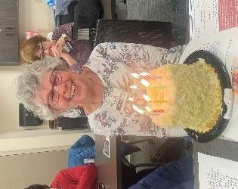
ANN FURLONG sends the following:
A grateful "Thank You" to all who sent cards for my special birthday. You are a wonderful group of friends.

*************************************
PAT GRZYBICKI thanks all of those who sent cards and/or condolences on the passing of her mother.

************************************
MIRIAM DAISLEY shares the following:
A ROAM (Reciprocal Organization of Associated Museums) pass can be obtained by purchasing a one-time entry-level membership at a participating institution for two people (approximately $100). You will then receive free admission to more than 500 museums nationwide including places like Carnegie, Frick, Warhol, etc. Call the Heritage Discovery Center at 814- 539-1889 for more information or to purchase.


MAY 2026

SUN | MON | TUES | WED | THURS | FRI | SAT
 |  |  |  |  | 1 | 2 Book Collect Ends
3 | 4 | 5 | 6 Pub Prog:  Jane Addams  7-8:30 pm BMHS | 7 | 8 | 9
10  MOTHER’S DAY | 11 | 12 Tues Bk  1 pm Ann Furlong’s | 13 Girls Day Westmoreland County Museum 2 pm | 14 Bks on Thurs 6 pm  Crow’s Nest | 15 | 16
17 | 18 Member Bus Mtg  4-7 pm  Highland Pk  One Book | 19 PRIMARY ELECTION  One Book | 20 Dining Club 5:45 pm Takumi  (College Pk Pl)  BYOB  One Book | 21 | 22 | 23
24/  /31 | 25 MEMORIAL DAY | 26 | 27 | 28 | 29 | 30

This Photo by Unknown Author is licensed under CC BY-NC
JUNE 2026
SUN | MON | TUES | WED | THURS | FRI | SAT
 | 1 | 2 | 3 | 4 | 5 | 6
7 | 8 | 9 | 10 | 11 Bks on Thurs 6 pm  Nyko’s | 12 | 13
14  FLAG DAY | 15 | 16 | 17 Dining Club 5:45 pm  El Jalisco | 18 | 19 | 20
21  FATHER’S DAY | 22 | 23 | 24 | 25 | 26 | 27
28 | 28 | 30

